Sungkit Yip
Research Fellow, Institute of Physics, Academia Sinica

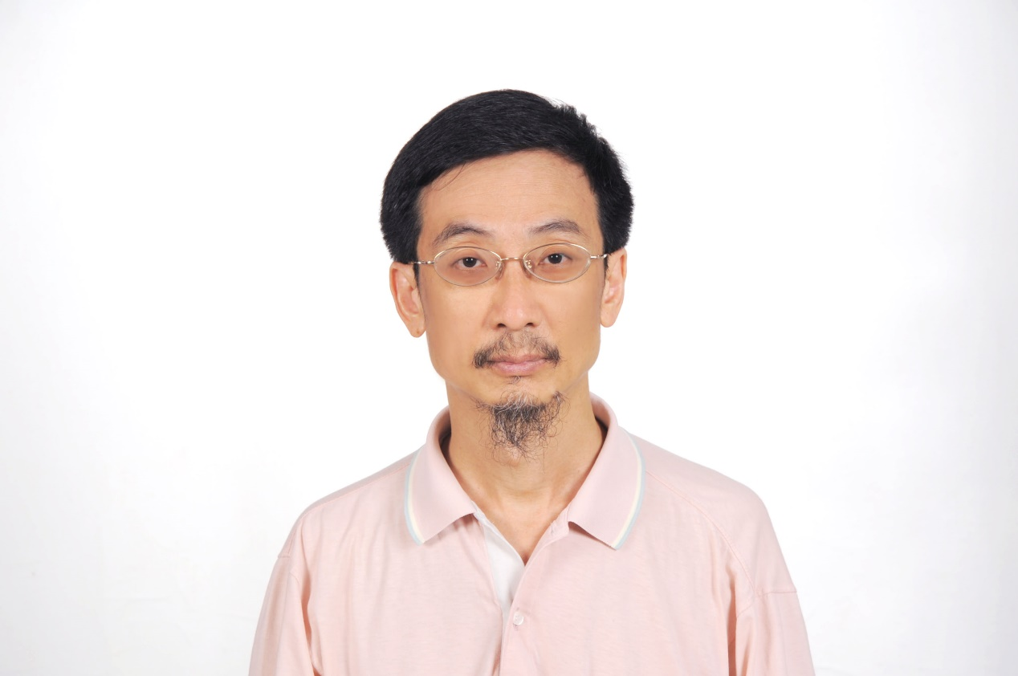

Honors and Awards:

2002 Outstanding Research Award, National Science Council, Taiwan
2003 Fellow, Physical Society of Republic of China (Taiwan).
2008 Academic Award, Ministry of Education, Taiwan
2010 Outstanding Referee, the American Physical Society

Time：2021/01/28 11:00-12:00
Location：
Title：Multicomponent Superconductors

Multicomponent Superconductors

Sungkit Yip

Institute of Physics,
Institute of Atomic and Molecular Sciences,
Academia Sinica, Taiwan;
and
National Center for Theoretical Sciences, Hsinchu, Taiwan.

I shall introduce superconductors and superfluids with internal degrees of freedom. A well-established example is superfluid 3He. Similar physics have been considered in “unconventional” superconductors (or rather superconductors with reduced symmetry), and more recently Bose-Einstein condensates with spin. I shall explain how these systems are different from their conventional or spinless counterparts. I shall in particular elaborate some of these points through our own work on doped Bi2Se3, which has been proposed to be a nematic superconductor.

